Ornaments as indicators of social change before and after European arrival at Kiwulan, Northeastern Taiwan

Li-Ying Wang

21 September, 2019

# Introduction

The direct impacts of European colonialism on indigenous communities in East Asia were much less conspicuous than in island Southeast Asia and Oceania. Direct European colonial rule throughout East Asia was rare and limited, and the question of long-lasting indirect impacts on local indigenous communities remains largely unanswered. Understanding the indirect effects of colonialism are important for detecting colonial impacts on indigenous peoples in the periphery of colonial control (Trabert 2017). In many parts of the world, the introduction of foreign trade goods by colonial traders into local indigenous societies caused substantial transformations of indigenous economic, cultural, and socio-political systems (Dietler 2005; Dietler 1997; Junker 1993; Silliman 2005). Consumption patterns of foreign goods can give insights into negotiations between colonized and colonizer, and the resistance and accommodations of indigenous people through their daily cultural practices (Dietler 2015; Given 2004; Mullins 2011; Scaramelli & Scaramelli 2005; Silliman 2001; Torrence & Clarke 2000; Voss 2005). Northeastern Taiwan is an ideal context to study peripheral colonial influence because although there was a prominent Spanish and Dutch colonial presence in Taiwan, the northeast region was isolated from intensive direct contact by the Xueshan Mountains.

This article describes ornaments excavated from Kiwulan (800-1900 AD), the largest Iron Age settlement on the Yilan plain in northeast Taiwan. The first recorded European presence in Yilan was a Spanish revenge attack on indigenous villages in 1632 (Borao 2001: 163). In 1647 the Dutch attacked villages and forced them to accept colonial rules and pay an annual tribute (Andrade 2007). According to Dutch census reports in 1650, Kiwulan was the largest indigenous settlement in the plain, with a population of 840 adults (Nakamura 1938: 12). Following defeat of Dutch by the Chinese general Koxinga in 1661-2, the Dutch abandoned northern Taiwan. Direct contact with Han Chinese is indicated by Qing dynasty census reports mentioning Yilan villages in 1821 (Yao 1996).

One of the most commonly traded types of object in this region were personal ornaments such as glass and stone beads (Chen 2007; Li & Chiu 2014; National Musuem of Taiwan History 2005). Personal adornments in the archaeological record are useful as signal of an individual’s status (Joyce 2005; Scaramelli & Scaramelli 2005). For example, the consumption of stone beads in Southeast Asia during Iron Age is often associated with increasing social stratification or socio-political complexity (Bellina 2014; Carter 2016; Francis 2002; Theunissen *et al.* 2000; Kenoyer 2000). In this paper, I explore archaeological ornaments from Kiwulan spanning the pre-European contact period, the period of Spanish and Dutch presence, and the period of Chinese presence. I address the question of whether indirect colonial influences on the indigenous populations can be detected through the ornament assemblages.

# Cultural context of ornaments in Yilan, northeastern Taiwan

Historical documents from the Spanish and Dutch in the early 17th century provide some information about the social life and culture of indigenous people in Northern Taiwan when the Europeans arrived. The Spanish founded Fort San Salvador at Keelung in 1626 and Fort San Domingo in 1629 at Tamsui, and sent missionaries to local indigenous settlements in this region for religious purposes (Blussé & Everts 2000: 343). A report by Dominican priest Fr. Jacinto Esquivel in 1632 mentioned that the Taparri, an indigenous tribe from northern Taiwan, usually used cuentas (agate beads) in exchange for necessities with other indigenous groups. This form of exchange was widespread and even the Spanish soldiers learned to use agate as bargaining chips for gambling (Li & Wu 2006: 132–49). Esquivel also recorded how indigenous people viewed agate pieces as prestige goods in their culture. An indigenous man who wanted to get married had to pay agate beads to the parents of his future wife. Also, agate or golden beads could be used to resolve conflicts in their daily lives (Li & Wu 2006: 151). Other records mention that the female shamans (majuorbol) in the tribe would use agate beads as magical items in ritual practice for body healing (Borao 2009: 122–51). Records of an indigenous funeral process document the use of agate beads in ritual contexts, with more agate beads, pottery, and cloth placed into the graves of more influential people to indicate a family’s higher prestige (Li & Wu 2006: 153). These historical accounts indicate that agate beads or golden beads were already treated as prestige goods before the arrival of the Europeans. These were likely introduced earlier from Chinese traders.

In 1642, the Dutch Vereenigde Oostindische Compagnie (VOC) defeated the Spanish and took over their forts in northern Taiwan. They introduced a feudal system in an attempt to control the indigenous communities by asking indigenous leaders to attend an annual ceremony for demonstrating their loyalty (Andrade 2007, ch. 9; Kang 2016, ch. 4). The Dutch provided beads and other goods based on the demands of Indigenous people to secure alliances in the annual ceremony or during traveling (Kang 2016, ch. 6). Thus, I assume that the Dutch feudal system resulted in an increase in the amount and diversity of ornaments in northeastern indigenous communities during this period.

Chinese historical records from 1829, 1837, and 1852 during the Qing dynasty [1616-1911] contain some notes on the purposes of ornaments from Yilan (Chen 1963: 228, 308; Ke 1993: 11, 126; Yao 1996: 77). According to those records, indigenous people in Yilan wore ornaments in ceremonial contexts to display their wealth and status. Among those ornaments, golden fish-shaped necklaces made of copper threads had high value due to their delicacy and the materials invested in production. These were usually possessed by wealthy people. Other people wore agate beads or glass beads on their head or neck to participate in ceremonies. In 1895, at the beginning of Japanese colonisation, a field survey for plains indigenous groups reported that golden necklaces were not used in Yilan at that time, but elderly people still used beads (Ino 1996: 227–32).

Recent ethnographic research with the living members of the Kavalan tribe describes how agate beads were used in divination practices, called “subli”, by female shamans (Liu 2008: 133–34). Interview records mention agate beads as valuable objects that are usually passed down from mother to daughter as heirlooms in shaman families, without knowing the exact origin. When not in use, beads were often hidden in safe places, such as on the roof beams. Modern ethnographic research shows that agate beads were not only used as decoration, but also played an important role in divination, consistent with observations from the European colonial period. Despite most Kavalan people today not knowing the specific origin of their agate beads, the high value of beads is still indicated in oral history and by their scarcity. In sum, we find multiple sources describing how local Indigenous people used ornaments in cultural contexts that represents some social roles or high status. However, compared to the European period, there are fewer mentions of beads in Chinese period and the descriptions are limited to clothing, but generally confirm the role of beads as status markers.

# Excavations at Kiwulan in northeastern Taiwan



Figure 1: Map showing the location of Kiwulan, and other places in northern Taiwan named in the text. Map data from naturalearthdata.com

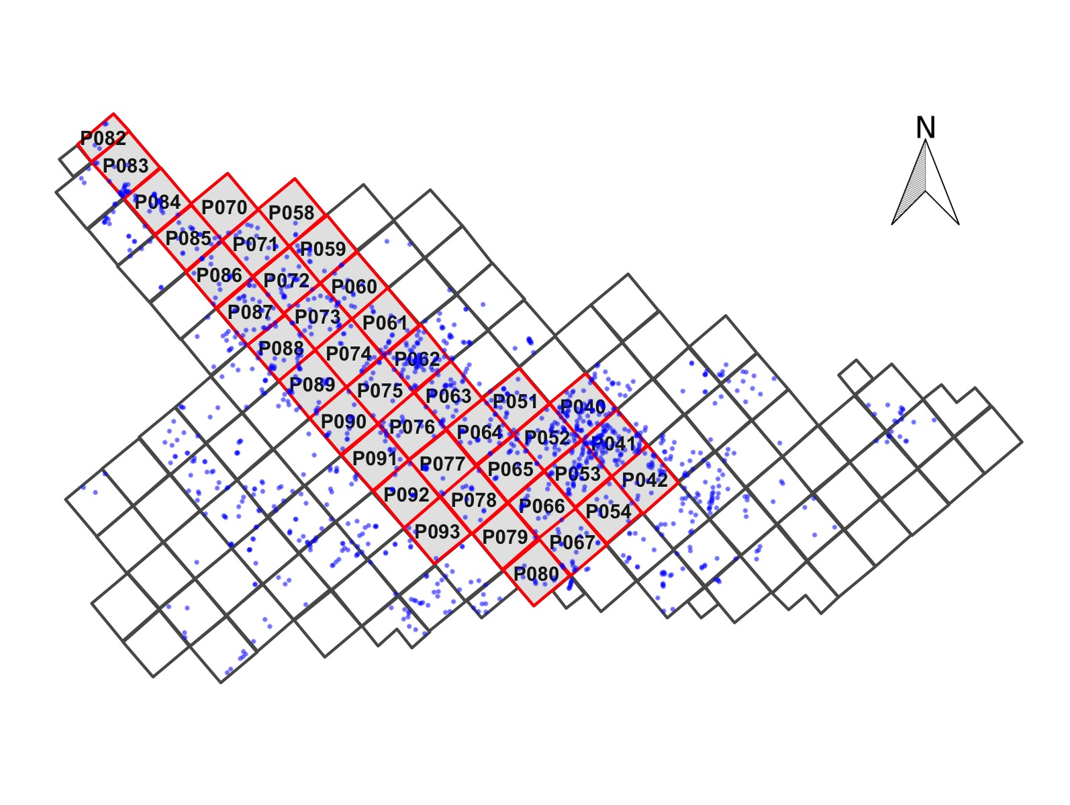

Figure 2: Map showing the largest section of excavation areas at Kiwulan, and the distribution of forty squares sampled in this paper presented in red with square ID number. Small dots represent the location of post-holes. Each square is 4 x 4 m

Kiwulan (Figure 1) is located at northern Yilan and was a rescue archaeology project that carried out from 2001 to 2004 in advance of water diversion project and construction of a road bridge. The total area includes eight open area sections of 262 excavation squares (4 m by 4 m) reaching 3,814 m2 in total (Chen 2007). The archaeological evidence includes a large amount of artefacts, burials, middens, post holes, wooden pillars, and stone structures, all of which indicates it was a settlement. Most ornaments were found in situ while digging and some were collected through screens with 2 mm and 1.5 mm mesh. The ornaments studied in this paper were found from 40 adjacent squares in the largest open area, located in the middle part of the excavation, see Figure 2. They were sampled because those units were stratigraphically intact with the least disturbance by modern construction activity, compared to excavation squares on the periphery of the site.

The chronology of Kiwulan can be divided into two phases represented by a Lower Layer Culture (700 - 1200 AD) and a Upper Layer Culture (1400 - 1900 AD) with a sterile layer in between. This chronology is based on the stratigraphy and a series of 32 radiocarbon dates (Chen 2007). This paper focuses on the Upper Layer Culture spanning from the late Iron Age to the historical period starting from the 17th century with the European presence in Taiwan.

Previous researchers divided the Upper Layer Culture component into six layers spanning from the 14th century to the 19th century with hundred year intervals according to the radiocarbon dates, excavation depth, consistency of contexts, and types of diagnostic porcelains such as blue and white porcelains (Hsieh 2009; Wang 2011). The layers were assigned numbers from 1 to 6 where L1 corresponds to the youngest layer and L6, the bottom layer, refers to the oldest layer. However, because the specific methods of assigning layers to a time period was not documented in detail for the previous chronology, I reexamined the excavation records to produce a new chronology for the sampled squares. For each sampled square I separated excavation units into three episodes of time: pre-European period (L5 and L6), European period (L4), and Chinese period (L2 and L1) to indicate the dominant foreign influence and cultural interaction for different time periods.

In the archaeological record, the approximate indicators of the start of the European influence at Kiwulan are the appearance of An-ping jars and stonewares (martavans/martaban) that were largely introduced to Taiwan during the early 17th century. They are frequently found in European shipwrecks from this period for transporting water, wine or other fluids on the long voyages. The jar shapes found at Kiwulan are typical of those found elsewhere in VOC sites occupied during the 17th century (Berrocal *et al.* 2018: 917; Cort 2017: 282; Grave & McNiven 2013; Ketel 2011; Klose & Schrire 2018: 131). I used the presence and absence of An-ping jars and stonewares, together with the radiocarbon dates, to identify excavation units associated with the pre-European and post-European periods.

European colonisation ended in 1662 when they were defeated by the kingdom of Tungning founded by Koxinga from China. Later in 1683, the Qing dynasty ruled over Taiwan and a large wave of Han Chinese migrated to Yilan during the late 18th century. The archaeological signature of the Chinese period at Kiwulan is the large amount and varieties of Chinese porcelains, clay stoves, and a few opium pipe-bowls that were identified as items commonly used in the daily life of Chinese and the use of bricks and tiles for architectural buildings (Hsieh 2009). Also, the description of the Chinese migration to Yilan can be seen from official Chinese records written in the early 19th century (Chen 1963; Ke 1993).

# The ornaments

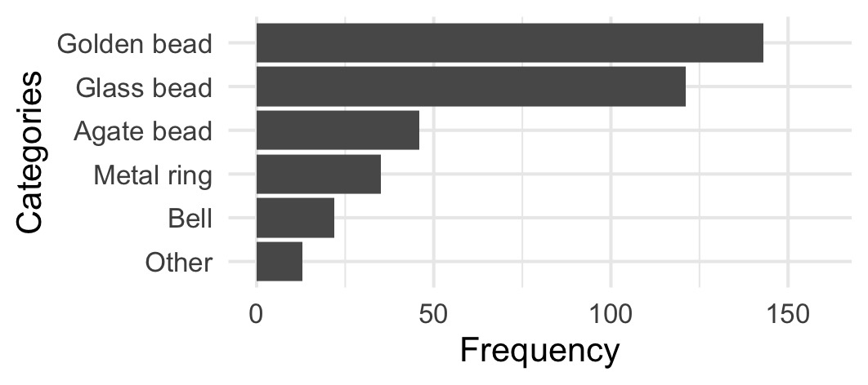

Figure 3: Frequency of the major class of ornaments at Kiwulan. Frequency represents artefact counts

Table 1: Ornament subtype at Kiwulan. The numbers represent artefact counts



Figure 4: Subtypes of ornament in each major class. A: agate beads, B: bells, C: glass beads and golden beads, D: metal rings. Photographs are presented in the same order as those subtypes in the table but from left to right instead. The photographs of B, C, D classes were from original excavation report (Chen 2007).

Ornaments from 40 sampling squares were excavated in-situ in different archaeological contexts, including 406 pieces from post-hole areas, 3173 pieces from 30 burials, and 27 pieces from middens. Burials unearthed a large amount of ornaments in the form of bead strings that consisted of hundreds to thousands of pieces. The ornaments from the burial context are not analyzed here since not many burials can be assigned to a time period with confidence. In this paper I focus on the post hole areas where 406 ornaments were recovered, which accounts for 46.5 % of the total number from the same context in the Upper Layer Culture at Kiwulan. Post hole areas represents domestic spaces suitable for testing for changes in the patterns of distribution relating to social organisation. Figure 3 shows that the most common ornament is golden bead with the number of 143, followed by 121 glass beads, 46 agate beads, 35 metal rings, and 22 metal bells (see also Figure 4). The variety of subtype and their individual frequency are summarized in Table 1 in terms of three time episodes.

# Reproducibility and open source materials

To enable re-use of materials and improve reproducibility and transparency (Marwick 2017), the entire R code (R Core Team 2019) used for all the analysis and visualisations contained in this paper is included in <http://doi.org/10.17605/OSF.IO/R8YGA>. Also in this version-controlled compendium (Marwick *et al.* 2018) are the raw data for all the tests reported here. All of the figures, tables, and statistical test results presented here can be independently reproduced with the code and data in this repository. The code is released under the MIT license, the data as CC-0, and figures as CC-BY, to enable maximum re-use.

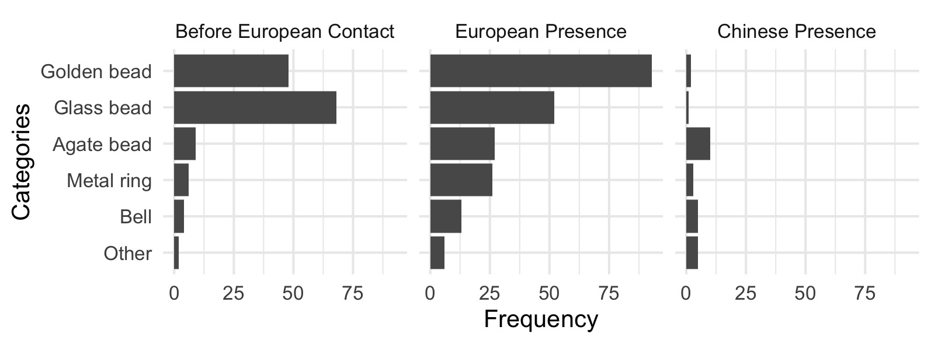

Figure 5: Frequency of the major ornament across different time periods.

# Results of hypothesis testing

## Changes in the frequencies of ornament types over time

Figure 5 shows the comparison of frequency for the major class of ornaments between different time periods at Kiwulan. The result of chi-square test for the number of ornaments (chi-square = 71.82, df = 8, p-value = $2.136325×{10}^{-12}$) shows that there is a non-random difference between the three time periods. It indicates that most ornament types were present before European contact. Ornament frequencies reached a peak during European period and then dropped during the Chinese period, especially for golden beads. This trend can be also seen on other ornaments including agate beads, metal rings, and bells. However, glass beads show a different pattern that indicates a higher frequency in the pre-European contact, and then a decrease in the European period and a further decrease in the Chinese period.

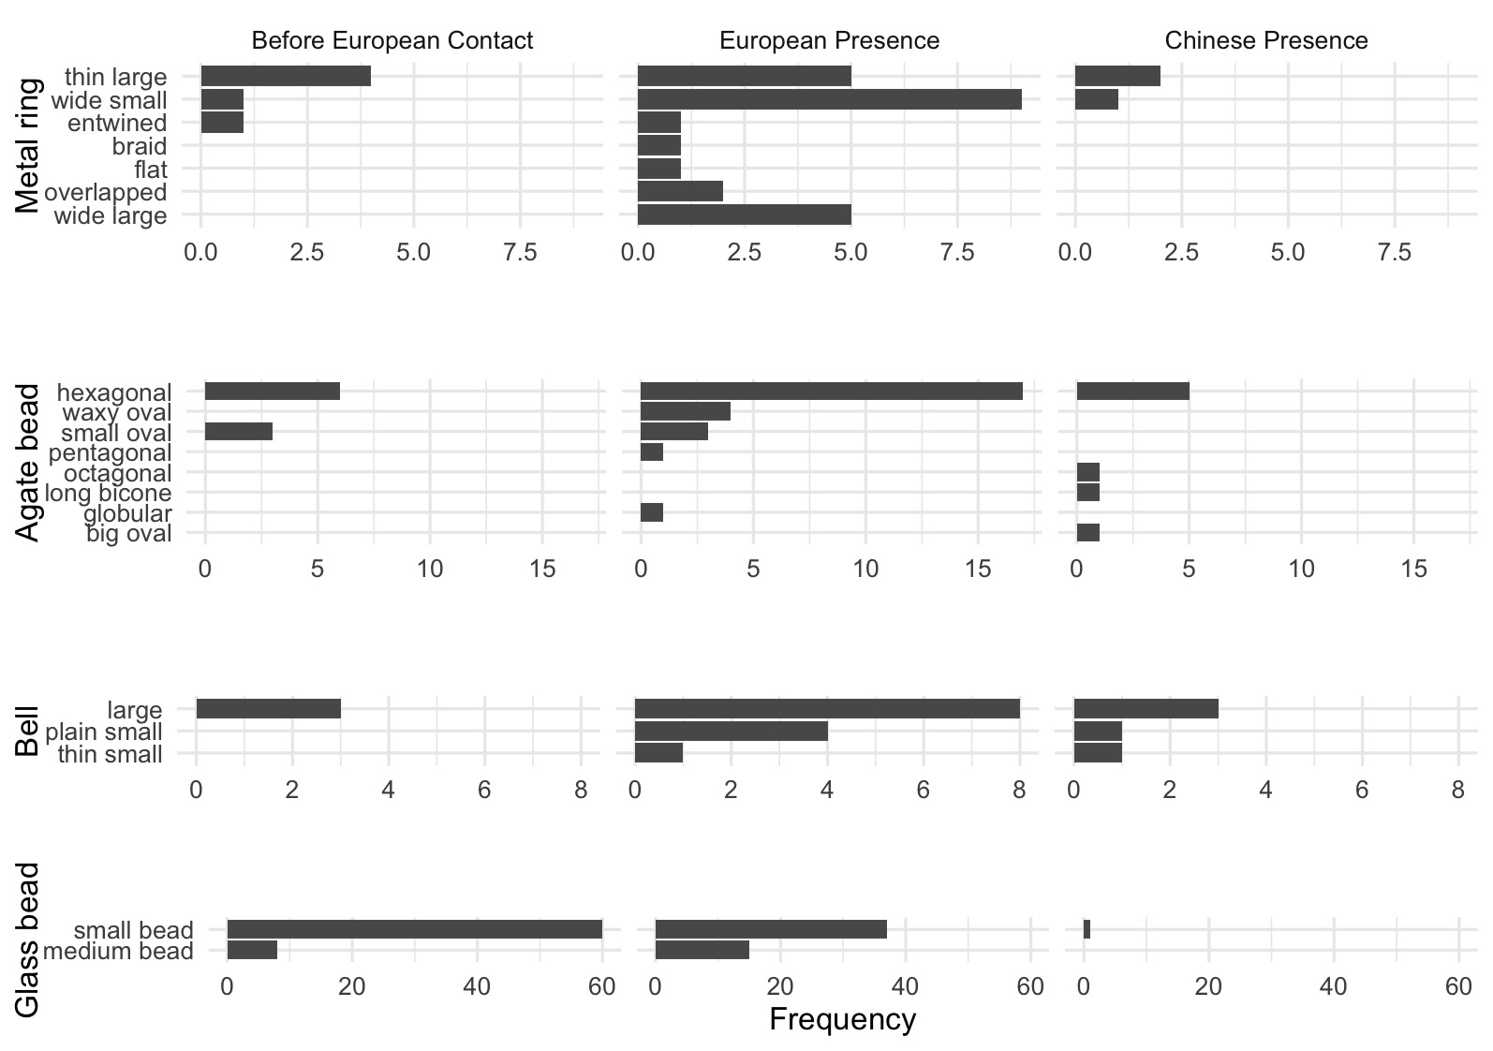

Figure 6: Frequency of ornament subtypes showing the changes in frequency across time periods for metal rings, agate beads, bells, and glass beads.

The distribution of frequency for subtypes in each major class are presented in Figure 6. Spearman’s correlation test shows that there is no significant relationship between diversity of subtypes and sample size (S = 173.16, rho = 0.39, p = $0.20438$). This indicates that the increases in diversity can be explained by the effects of culture interaction instead of effects of sample size. According to the frequency, agate beads and metal rings have greater quantity and variety of shapes compared to copper bell and glass beads during the European period. The greater varieties for agate beads and metal rings might indicate multiple origins due to participation in global trade networks stimulated by the Europeans. In contrast, copper bells and glass beads have less variety, but glass beads have a larger number because they were usually found in a cluster that indicates the original use as strings or necklaces. The common shape for copper bells is the large shape with a wide variety of human faces as a motif, while the common shape for glass beads is a bead with length less than 1 cm that are often identified as Indo-Pacific beads, the most common type that had been widespread in Southeast Asian sites since 300 BC (Francis 2002).

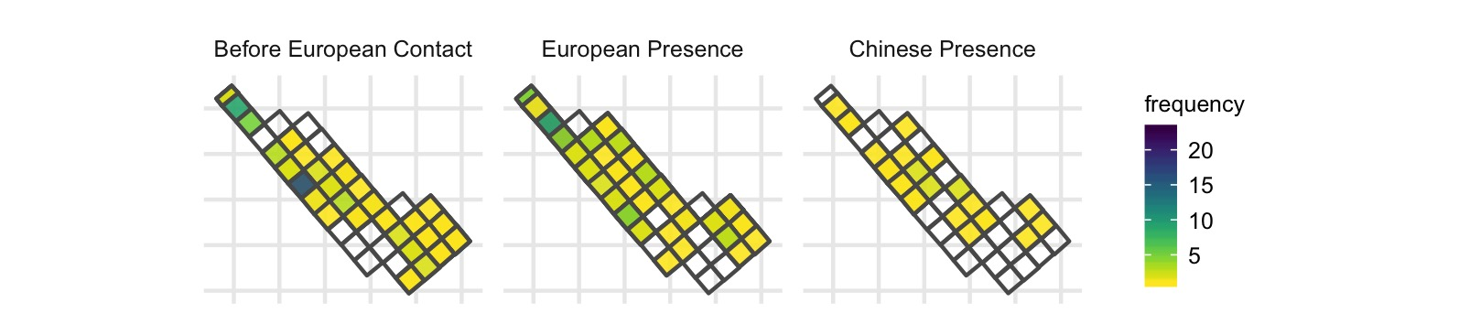

Figure 7: Spatial pattern of all class of ornament by time periods

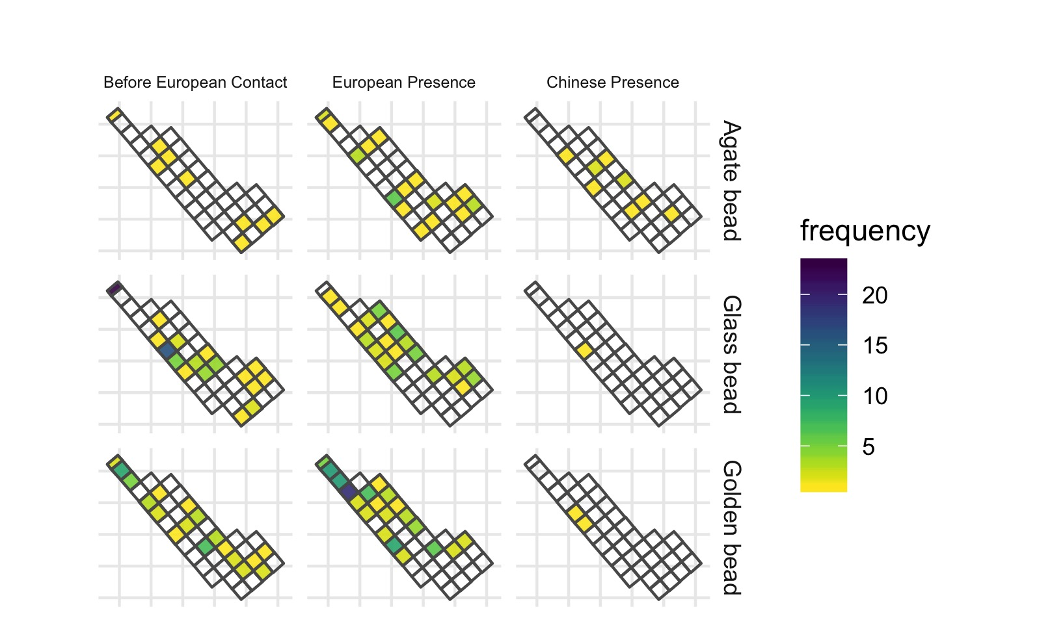

Figure 8: Spatial pattern for ornament class by time periods, only those types with more than 5 pieces are shown here

## Changes in patterns of the spatial distribution of ornament types

Figure 7 presents the spatial distribution of all ornaments from the research area for each time period. Before the European arrival, a greater amount of ornaments were found at the northern and middle parts of the research area. During the European period, ornaments were more widespread, with some clusters on the northern part. During the Chinese period the distribution is more even again. Figure 8 presents the distribution for the major ornament classes individually, some clusters across the area can be observed during the European period, such as golden beads and agate beads. However, there seems to be no clear consistent pattern across those different ornaments. Each class shows its own pattern where the squares with higher number of ornaments distributed separately and independently. For example, the cluster of golden beads was found at the northern part, while the cluster of agate beads was found in the middle part. In contrast, there are multiple clusters of metal rings that are distributed separately across the research area. Copper bells were usually found individually and seem randomly distributed across the area. In the Chinese period, both the amount and density of different classes of ornaments decreased.

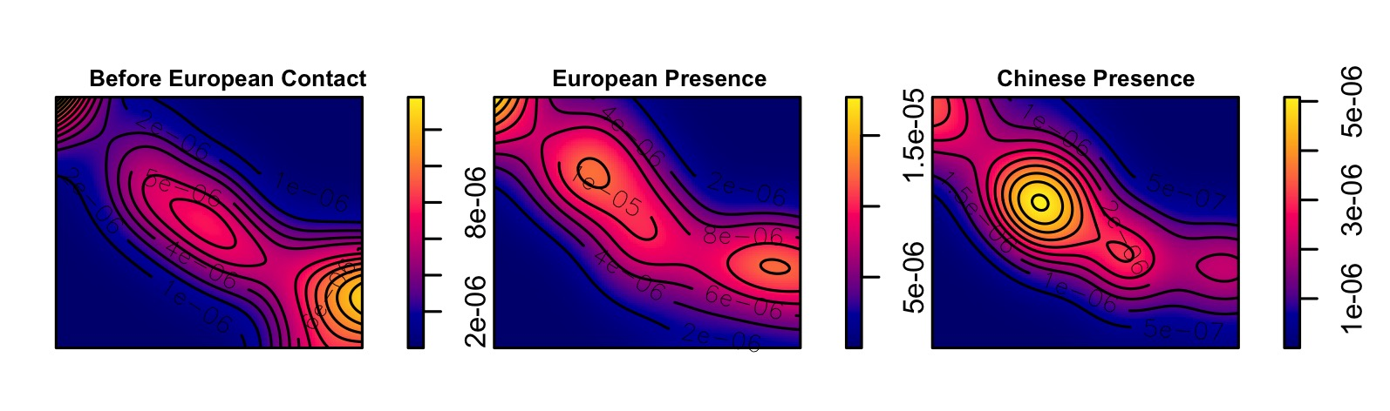

Figure 9: Kernel density map for ornaments by periods. Used the bandwidth based on Silverman (1986)’s rule of thumb.

## Point pattern analysis of ornament distribution

I used point pattern analysis to examine whether the distribution of ornaments was uneven in non-random ways that could reflect changes in social inequality. Point pattern analysis is a way to assess whether the distribution of sites or artefacts represent some “hotspots” produced by non-random processes, implying the influence of social processes (Bevan & Lake 2016; Ducke 2015). Hotspots in the pattern of ornaments could indicate changes in social organisation due to culture interaction. To explore ornament distributions I used the intensity approach that focuses on the average density of points across space. During excavation, ornament locations were only recorded to the square (4 x 4 m). To prepare the location data for point pattern analysis, I assigned each ornament to a random coordinate pair located in square it was recovered from. The next step was to subset the ornaments into three groups for three time periods. Finally I computed the kernel densities for each time period for comparison.

Kernel density estimations (KDE) estimate the probability of the density of ornaments across space by creating a continuous, smooth density surface across space. Here I use KDE to visualize core areas of ornaments and surrounding neighborhoods (Bonnier *et al.* 2019; Cortegoso *et al.* 2016). Density values of artefacts per square meter were calculated for each cell.

The results show that there is one major core area during the pre-European period, multiple core areas during European period, and a single core during the Chinese period according to the kernel density maps (Figure 9). It seems that there are three consistent sub-regions with a core area that shifts over time. The distribution might indicate different household-based social groups who possessed more ornaments. The multiple groups during European period might reflect more unequal consumption of ornaments across the site, relative to other periods, to indicate social processes caused by human behavior. However, it could also just a random pattern resulting from bigger sample size. In addition, the generation of core areas might be biased due to small sample sizes, for example, a few ornaments found at one single square during the Chinese period could create an obvious hot spot. To further evaluate these patterns, we test the hypothesis that the distribution of ornaments is not randomly distributed to determine if social processes might explain ornament distributions.

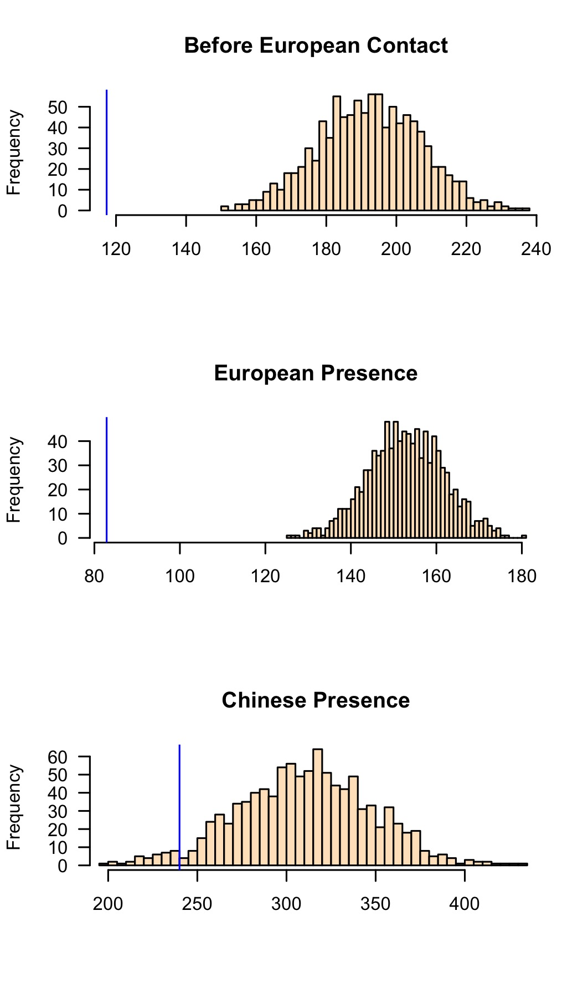

Figure 10: Histograms of simulated ANN values from 1000 simulations for three time periods. X values represent ANN expected value under a completely random process resulted from simulated pattern. Each sample distribution presents the null hypothesis with the blue line indicating the observed ANN value.

To test this hypothesis about the randomness of spatial locations, I used a Monte Carlo method to simulate average nearest-neighbor distances (ANN). Our null hypothesis is that the distribution of ornaments is consistent with a completely random process. We simulated the locations of ornaments across the space 1000 times for each time period. The observed data was compared to the random patterns generated by simulated processes to determine if our data are randomly distributed or not. Figure 10 shows the distributions of the ANN distances calculated on 1000 simulations of ornament locations. The results show that 100% of the simulated values are much greater than our observed ANN value during the European period, which means the ornaments have non-random clustered distributions. A similar, but less extreme, result is also observed during the pre-European period. The observed distribution of ornaments is more similar to the random distributions during the Chinese period, with about one third of the simulated values are greater than our observed ANN value. This testing reveals that the clustered distributions of ornaments during the pre-European and European periods might reflect the presence of different social groups. Moreover, the clustering of ornaments during the European period is highly non-random, might potentially indicating that some of the social changes leading to different degrees of access foreign ornaments or a concentration of power to control the distribution of ornaments at Kiwulan.

# Discussion

The results show there was a greater diversity of ornaments types and materials at Kiwulan during the European presence. This might result from the large scale exchange network that stimulated the circulation of different ornament classes. However, the frequency of overall ornaments and each subtype declines significantly during the Chinese period. This may be due to a smaller scale of trading network, the overall decline of the indigenous population in Yilan, and adopting the mortuary practices of Han Chinese. Since the end of the 18th century, many indigenous people moved southwards to Hualien due to population pressure caused by Han Chinese immigrants (Chen 2007).

Spatial patterns of ornaments shows that their distribution was clustered during the pre-European and European period. Hypothesis testing for spatial patterns indicates that these clusters are non-random, and are most highly concentrated during the European period. Because ethnographic evidence indications that trade ornaments were prestige goods in prehistoric Northeastern Taiwan, this spatial clustering may indicate that a degree of social inequality was present before European contact and then it was reinforced and amplified during the European period. In addition, there was a burial dated to 17th century unearthed 60 golden beads above the average of 2-3 pieces in the pre-European period, further indicating increasing social inequality (Chen 2007; Cheng 2008).

How might these results fit into a bigger picture of social change at periphery of colonial systems? We may get some insight into the general pathways that led to social inequality in northeastern Taiwan by considering how people have achieved and maintained power in a wide variety of societies (Drennan *et al.* 2010; Feinman 2000; Ames 2010; Bowles *et al.* 2010). For example, the corporate/network model proposed by Feinman (2000) expands traditional hierarchical complexity to provide a comparative basis for distinct strategies for power. In the network mode, inequality develops when individuals accumulate wealth through their individual networks and people use their wealth to attract factions, control resources, and monopolize trade networks. In contrast, the corporate mode stresses shared power across different groups and sectors, integrative ceremonies and rituals, and large cooperative labor tasks (Feinman 2000; Siegel 1999).

We may consider that Yilan social organisation went from corporate mode before the European arrival, then transitioned into network mode during the European presence, then back to corporate mode in the Chinese period. The small number of ornaments, and less concentrated distribution during the pre-European period is consistent with shared power and wealth of the corporate mode. The long-distance trade network introduced by the Europeans resulted in the appearance of a network mode due to competition among ambitious individuals for prestige, wealth, or power through collecting trade goods (Brumfiel 1994; Clark & Blake 1994). Because of the weak direct control from the European colonizers in northeastern Taiwan, it implies that local leaders might have flexibility to manipulate European colonial image, expand personal power, and monopolize the high-value trade goods (Kang 2012). During the Chinese period, the decreasing frequency and diversity of ornaments show a decline in the production, use and discard of ornaments at Kiwulan. This reflects the smaller scale of exchange networks, with limited sources of ornaments, and limited opportunities for individuals accumulate wealth.

# Conclusion

Examination of the indirect influence of colonialism can reveal how peripheral areas were influenced by the colonial activities or involved in the colonial economy centred in the major European colonies (Trabert 2017). Kiwulan in Northeastern Taiwan is an important case study as an East Asian location that was relatively isolated and peripheral, and yet connected by regional and global trade networks. Kiwulan can provide valuable insights into the discussion of indirect colonial influence on the local societies living beyond the borders of direct European colonial occupation. The frequency and spatial distribution of body ornaments at Kiwulan present three distinct patterns during different dominant culture interaction periods. The greater amount and diversity of ornament types during the European period reflects international exchanges in a colonial context. Ornaments were viewed as prestige goods in local indigenous culture before European contact. After the arrival of the Europeans, the exotic and powerful image carried by those ornaments may be intensified that further signals wealth and privileged trading connections with European colonists for the inhabitants of Kiwulan. These symbolic values may have stimulated more competition between aggrandizing individuals for prestige and wealth accumulation at Kiwulan, which might have resulted in an increase in social inequality.

This study demonstrates that foreign ornaments can be a proxy to detect indirect colonial influence on local indigenous populations. Ornaments can give insights into the amplification of social inequality stimulated by European colonisation. It also shows the agency of indigenous people to incorporate ornaments into their social system and use them in their daily lives to display or intensify status differences. Future work could extend this approach to studies of other trade goods such as ceramics. We have introduced here the corporate/network model for understanding the dynamics of social inequality at Kiwulan, and future tests of this should include analysis of pottery production and standardisation, and mortuary practices.

##### pagebreak

# References

Ames, K.M. 2010. On the evolution of the human capacity for inequality and/or egalitarianism, in G. Feinman & T.D. Price (ed.) *Pathways to power: New perspectives on the emergence of social inequality*: 15–44. New York: Springer.

Andrade, T. 2007. *How Taiwan became chinese : Dutch, spanish, and han colonization in the seventeenth century*. New York: Columbia University Press.

Bellina, B. 2014. Maritime silk roads’ ornament industries: Socio-political practices and cultural transfers in the south china sea *Cambridge Archaeological Journal* 24. Cambridge University Press: 345–77.

Berrocal, M.C., E.S. Herrero., M.G. Moret., A.U. González., M.T. Pérez., S.C. Rodrı'guez., A. Chevalier., F. Valentin. & C.-h. Tsang. 2018. A comprised archaeological history of taiwan through the long-term record of heping dao, keelung *International Journal of Historical Archaeology* 22. Springer: 905–40.

Bevan, A. & M. Lake. 2016. Intensities, interactions, and uncertainties: Some new approaches to archaeological distributions, in A. Bevan & M. Lake (ed.) *Computational approaches to archaeological spaces*: 27–52. Routledge.

Blussé, L. & N. Everts. 2000. *(FEII) the formosan encounter. Notes on formosa’s aboriginal society, a selection of documents from dutch archival sources. Volume ii: 1636-1645*. Taipei: Shung Ye Museum of Formosan Aborigines, Taipei.

Bonnier, A., M. Finné. & E. Weiberg. 2019. Examining land-use through gis-based kernel density estimation: A re-evaluation of legacy data from the berbati-limnes survey *Journal of Field Archaeology* 44. Taylor & Francis: 70–83.

Borao, H., J. E. 2001. *(SIT, pp. 1-343). Spaniards in taiwan, vol. I (1582–1641)*. Taipei: SMC Publishing.

Borao, J.E. 2009. *The spanish experience in Taiwan, 1626-1642: The baroque ending of a renaissance endeavor*. Hong Kong: Hong Kong University Press.

Bowles, S., E. Smith. & M. Mulder. 2010. The emergence and persistence of inequality in premodern societies *Current anthropology* 51: 7–17.

Brumfiel, E.M. 1994. Factional competition and political development in the new world: An introduction, in E.M. Brumfiel & J. Fox (ed.) *Factional competition and political development in the new world*: 3–13. Cambridge: Cambridge University Press.

Carter, A.K. 2016. The production and exchange of glass and stone beads in southeast asia from 500 bce to the early second millennium ce: An assessment of the work of peter francis in light of recent research *Archaeological Research in Asia* 6. Elsevier: 16–29.

Chen, S. 1963. *Kavalan ting zhi [kavalen culture history], taiwan wen xian cong kan di 106 zhong [taiwan literature series: 106]*. Taipei: Economic Research Office, Bank ofTaiwan.

Chen, Y.-p. 2007. *Qi wu lan yi zhi qiang jiu fa jue bao gao [ report on the archaeological excavations at ki-wu-lan site]*. Yilan, Taiwan: Lanyang museum.

Cheng, C.-F. 2008. Qi wu lan yi zhi yu she nei yi zhi chu tu bo li zhu de xiang guan yan jiu [studies of glass beads excavated from kivulan and shenei site, taiwan]. Master’s thesis.

Clark, J.E. & M. Blake. 1994. The power of prestige: Competitive generosity and the emergence of rank societies in lowland mesoamerica *Factional competition and political development in the New World*, 17–30.

Cort, L.A. 2017. Container jars from the maenam noi kilns, thailand use and reuse along maritime trade routes in asia *Bulletin de l’École française d’Extrême-Orient* 103. École française d’Extrême-Orient: 267–96.

Cortegoso, V., R. Barberena., V. Durán. & G. Lucero. 2016. Geographic vectors of human mobility in the andes (34–36° s): Comparative analysis of ‘minor’obsidian sources *Quaternary International* 422. Elsevier: 81–92.

Dietler, M. 1997. The iron age in mediterranean france: Colonial encounters, entanglements, and transformations *Journal of World Prehistory* 11. Springer: 269–358.

— 2005. The archaeology of colonization and the colonization of archaeology: Theoretical challenges from an ancient mediterranean colonial encounter, in G. Stein (ed.) *The archaeology of colonial encounters: Comparative perspectives*: 33–68. Santa Fe: NM: Sch. Am. Res. Press.

— 2015. *Archaeologies of colonialism: Consumption, entanglement, and violence in ancient mediterranean france*. Univ of California Press.

Drennan, R.D., C.E. Peterson. & J.R. Fox. 2010. Degrees and kinds of inequality, in *Pathways to power*: 45–76. Springer.

Ducke, B. 2015. Spatial cluster detection in archaeology: Current theory and practice, in J.A. Barcelo & I. Bogdanovic (ed.) *Mathematics and archaeology*: 352–68. Barcelona, Spain: CRC Press Boca Raton.

Feinman, G.M. 2000. Corporate/network: New perspectives on models of political action and the puebloan southwest *Social Theory in Archaeology, University of Utah Press, Salt Lake City*, 31–51.

Francis, P. 2002. *Asia’s maritime bead trade: 300 bc to the present*. University of Hawaii Press.

Given, M. 2004. *The archaeology of the colonized*. London; New York: Routledge.

Grave, P. & I.J. McNiven. 2013. Geochemical provenience of 16th–19th century ce asian ceramics from torres strait, northeast australia *Journal of Archaeological Science* 40. Elsevier: 4538–51.

Hsieh, E. 2009. Yi lan qi wu lan yi zhi chu tu wai lai tao ci qi zhi xiang guan yan jiu [the study of imported ceramics excavated at the ki-wu-lan site, i-lan]. Master’s thesis.

Ino, K. 1996. *Ping pu zu diao cha lu hang :Yi neng jia ju (tai wan tong xin) xuan ji [field investigation trips at plains indigenous peoples: Ino kanori (taiwan letters)]*. Taipei: Yuan Liou.

Joyce, R.A. 2005. Archaeology of the body *Annual Review of Anthropology* 34. Annual Reviews: 139–58.

Junker, L.L. 1993. Craft goods specialization and prestige goods exchange in philippine chiefdoms of the fifteenth and sixteenth centuries *Asian Perspectives*. JSTOR, 1–35.

Kang, P. 2012. He lan dong yin du gong si zhi xia de ga ma lan di qu te zhi [charateristics of kavalan under colonial rule of dutch east India companies], in M.-C. Hsu & S.-Y. Li (ed.) *Exploring kiwulan: The ninth academic conference of yilan study*, 35: 291–317. Yilan: Institute of Yilan County History.

— 2016. *Colonial imagination and local variations: The dutch east india company and the formosan austronesians*. Lian-jing.

Ke, P. 1993. *Kavalan zhi lue [record of kavalen]*. Nantou: Historical Records Committee of Taiwan Provincial Government.

Kenoyer, J.M. 2000. Wealth and socioeconomic hierarchies of the indus valley civilization, in F.A. Janet Richards Mary Van Buren (ed.) *Order, legitimacy and wealth in early states*: 90–112. Cambridge University Press Cambridge.

Ketel, C. 2011. Identification of export porcelains from early 17th century voc shipwrecks and the linkage to their cultural identification, in D. Core (ed.) *The 2011 asia-pacific regional conference on underwater cultural heritage proceedings*: 1–14. Manila, Philippines.

Klose, J. & C. Schrire. 2018. Asian ceramic collections from voc sites at the cape, in C. Schrire (ed.) *Historical archaeology in south africa: Material culture of the dutch east india company at the cape*: 101–41. Taylor; Francis.

Li, C.-y. & S.-j. Chiu. 2014. A report on excavations in the yi-lang agricultural vocational high school site, 2000-2008 *Field Archaeology of Taiwan* 17: 59–120.

Li, Y.-z. & M.-z. Wu. 2006. *Qing zai xi ban ya ren zai tai wan, 1626-1642 [the spanish in Taiwan]*. Nantou: Taiwan Historica.

Liu, P.-c. 2008. *Identity, gender and settlement: Ritual studies of changing kavalan*. Nantou: Council of Indigenous Peoples, Executive Yuan: Taiwan Historica.

Marwick, B. 2017. Computational reproducibility in archaeological research: Basic principles and a case study of their implementation *Journal of Archaeological Method and Theory* 24. Springer: 424–50.

Marwick, B., C. Boettiger. & L. Mullen. 2018. Packaging data analytical work reproducibly using r (and friends) *The American Statistician* 72. Taylor & Francis: 80–88.

Mullins, P.R. 2011. The archaeology of consumption *Annual Review of Anthropology* 40. Annual Reviews: 133–44.

Nakamura. 1938. Overgekomen brieven en papieren. [The dutch cencus record for indigenous peoples in taiwan] *Southern Anthropological Studies* 4: 12.

National Musuem of Taiwan History, A. group in. 2005. Taiwan under dutch and spanish: A report of historical archaeological research in northern taiwan. Taipei: National Musuem of Taiwan History.

R Core Team. 2019. *R: A language and environment for statistical computing*. Vienna, Austria: R Foundation for Statistical Computing. <https://www.R-project.org>.

Scaramelli, F. & K.T. de Scaramelli. 2005. The roles of material culture in the colonization of the orinoco, venezuela *Journal of Social Archaeology* 5. Sage Publications Sage CA: Thousand Oaks, CA: 135–68.

Siegel, P.E. 1999. Contested places and places of contest: The evolution of social power and ceremonial space in prehistoric Puerto Rico *Latin American Antiquity*, 209–38.

Silliman, S. 2001. Agency, practical politics and the archaeology of culture contact *Journal of social archaeology* 1. Sage Publications Sage CA: Thousand Oaks, CA: 190–209.

Silliman, S.W. 2005. Culture contact or colonialism? Challenges in the archaeology of native North America *American Antiquity*, 55–74.

Theunissen, R., P. Grave. & G. Bailey. 2000. Doubts on diffusion: Challenging the assumed indian origin of iron age agate and carnelian beads in southeast Asia *World archaeology* 32: 84–105.

Torrence, R. & A. Clarke. 2000. Negotiating difference: Practice makes theory for contemporary archaeology in Oceania, in R. Torrence & A. Clarke (ed.) *The archaeology of difference : Negotiating cross-cultural engagements in Oceania*: 1–31. London; New York: Routledge.

Trabert, S. 2017. Considering the indirect effects of colonialism: Example from a great plains middle ground *Journal of Anthropological Archaeology* 48. Elsevier: 17–27.

Voss, B.L. 2005. From casta to californio: Social identity and the archaeology of culture contact *American Anthropologist* 107: 461–74.

Wang, L.-Y. 2011. Yi lan qi wu lan yi zhi chu tu zhuang shi pin zhi xiang guan yan jiu [a research of ornaments excavated at ki-wu-lan site, i-lan]. Master’s thesis.

Yao, ying. 1996. *Dong cha ji lue [record of taiwan], taiwan wen xian cong kan di 007 zhong [taiwan literature series: 007]*. Nantou: Taiwan Historica.

##### pagebreak